REBOUND

A PROJECT REPORT

Submitted by

AKSHITA SHARMA [RA2211026010268]
ANSHITA SRIVASTAVA [RA2211026010278]

Under the Guidance of

Dr. R. SIVA

(Associate Professor, Department of Computational Intelligence)

in partial fulfillment of the requirements for the degree of

BACHELOR OF TECHNOLOGY

in

COMPUTER SCIENCE ENGINEERING

with specialization in Artificial Intelligence and Machine Learning


DEPARTMENT OF COMPUTATIONAL INTELLIGENCE

COLLEGE OF ENGINEERING AND TECHNOLOGY
SRM INSTITUTE OF SCIENCE AND TECHNOLOGY

KATTANKULATHUR- 603 203

MAY 2026


Department of Computational Intelligence

SRM Institute of Science & Technology

Own Work Declaration Form

This sheet must be filled in (each box ticked to show that the condition has been met). It must be signed and dated along with your student registration number and included with all assignments you submit – work will not be marked unless this is done.

Degree/Course : | BTech in Computer Science Engineering with Specialization in Artificial Intelligence and Machine Learning
Student Name : | Akshita Sharma, Anshita Srivastava
Registration Number : | RA2211026010268, RA2211026010278
Title of Work : | Rebound
We hereby certify that this assessment compiles with the University’s Rules and Regulations relating to academic misconduct and plagiarism, as listed in the University Website, Regulations, and the Education Committee guidelines.

We confirm that all the work contained in this assessment is our own except where indicated, and that We have met the following conditions:

- Clearly referenced / listed all sources as appropriate
- Referenced and put in inverted commas all quoted text (from books, web, etc)
- Given the sources of all pictures, data etc. that are not my own
- Not made any use of the report(s) or essay(s) of any other student(s) either past or present
- Acknowledged in appropriate places any help that I have received from others (e.g. fellow students, technicians, statisticians, external sources)
- Compiled with any other plagiarism criteria specified in the Course handbook / University website
We understand that any false claim for this work will be penalized in accordance with the University policies and regulations.

DECLARATION:
I am aware of and understand the University’s policy on Academic misconduct and plagiarism and I certify that this assessment is our own work, except where indicated by referring, and that I have followed the good academic practices noted above.

Akshita Sharma [RA2211026010268] Anshita Srivastava [RA2211026010278]

SRM INSTITUTE OF SCIENCE AND TECHNOLOGY KATTANKULATHUR – 603 203

BONAFIDE CERTIFICATE

Certified that 21CSP401L/21CSP402L – Major Project [21CSP403L- Internship] report titled “REBOUND” is the bonafide work of “AKSHITA SHARMA[RA2211026010268], ANSHITA SRIVASTAVA[RA2211026010278]” who carried out the project work under my supervision. Certified further, that to the best of my knowledge the work reported herein does not form any other project report or dissertation on the basis of which a degree or award was conferred on an earlier occasion on this or any other candidate.

SIGNATURE SIGNATURE

Dr. R. SIVA DR. R. ANNIE UTHRA
SUPERVISOR  ASSOCIATE PROFESSOR  DEPARTMENT OF COMPUTATIONAL INTELLIGENCE |  | PROFESSOR AND HEAD OF DEPARTMENT  DEPARTMENT OF COMPUTATIONAL INTELLIGENCE
EXAMINER 1 EXAMINER 2

ACKNOWLEDGEMENTS

We express our humble gratitude to Dr. C. Muthamizhchelvan, Vice-Chancellor, SRM Institute of Science and Technology, for the facilities extended for the project work and his continued support.

We extend our sincere thanks to Dr. Leenus Jesu Martin M, Dean-CET, SRM Institute of Science and Technology, for his invaluable support.

We wish to thank Dr. Revathi Venkataraman, Professor and Chairperson, School of Computing, SRM Institute of Science and Technology, for her support throughout the project work.

We encompass our sincere thanks to, Dr. M. Pushpalatha, Professor and Associate Chairperson - CS, School of Computing and Dr. C Lakshmi, Professor and Associate Chairperson -AI, School of Computing, SRM Institute of Science and Technology, for their invaluable support.

We are incredibly grateful to our Head of the Department, Dr. R. Annie Uthra, Department of Computational Intelligence, SRM Institute of Science and Technology, for her suggestions and encouragement at all the stages of the project work.

We want to convey our thanks to our Project Coordinators, Panel Head, and Panel Members Department of Computational Intelligence, SRM Institute of Science and Technology, for their inputs during the project reviews and support.

We register our immeasurable thanks to our Faculty Advisor Dr. Nagendra Prabhu S, Department of Computational Intelligence, SRM Institute of Science and Technology, for leading and helping us to complete our course.

Our inexpressible respect and thanks to our guide, Dr. R. Siva Department of Computational Intelligence, SRM Institute of Science and Technology, for providing us with an opportunity to pursue our project under his mentorship. He provided us with the freedom and support to explore the research topics of our interest. His passion for solving problems and making a difference in the world has always been inspiring.

We sincerely thank all the staff members of Department of Computational Intelligence, School of Computing, S.R.M Institute of Science and Technology, for their help during our project. Finally, we would like to thank our parents, family members, and friends for their unconditional love, constant support and encouragement

Authors

ABSTRACT

Systematic performance analysis in sports requires structured and accessible performance data. However, amateur athletes are not offered suitable means of efficiently recording their game statistics. This means that their performance is not well documented. The study seeks to create a centralized game logging system that is effective in analyzing performance data. The system is intended to offer a unified platform that can be used in documenting game events, recording statistics, and retrieving analysis based on aggregated data. The system is based on a mobile platform that ensures performance tracking is consistent. The study’s findings highlight the need for centralized game logging in performance documentation and analysis. By integrating a mobile interface with a cloud-based data infrastructure, the platform supports consistent performance tracking and improved accessibility of sports data. The results demonstrate the centralized game logging can enhance performance documentation and provide meaningful analytical insights for athletes and coaches.

TABLE OF CONTENT

CHAPTER NO. TITLE PAGE NO.

1 INTRODUCTION 1
  - Introduction to Project 1
  - Problem Statement 1
  - Motivation 2
  - Sustainable Development Goal of the Project 3
2 LITERATURE SURVEY 4
2.1 Overview of the Research Area 4
2.2 Existing Models and Frameworks 4
2.3 Limitations Identified from Literature Survey (Research Gaps) 5
2.4 Research Objectives 5
2.5 Product Backlog (Key user stories with Desired outcomes) 6
2.5 Plan of Action (Project Road Map) 6
3 SPRINT PLANNING AND EXECTION METHODOLOGY 8
3.1 SPRINT I User Onboarding and Team Establishment 8
3.1.1 Objectives with user stories of Sprint I 8
3.1.2 Functional Document 8
3.1.3 Architecture Document 10
3.1.4 Outcome of objectives/ Result Analysis 11
3.1.5 Sprint Retrospective 12 3.2 SPRINT II Game Logging and Performance Analytics 13
3.2.1 Objectives with user stories of Sprint II 13
3.2.2 Functional Document 14
3.2.3 Architecture Document 16
3.2.4 Outcome of objectives/ Result Analysis 17
3.2.5 Sprint Retrospective 19
3.3 SPRINT III Administrative Control and System Refinement 20
3.3.1 Objectives with user stories of Sprint III 20
3.3.2 Functional Document 20
3.3.3 Architecture Document 22
3.3.4 Outcome of objectives/ Result Analysis 23
3.3.5 Sprint Retrospective 25
4 RESULTS AND DISCUSSIONS 27
4.1 Performance Evaluation 27
4.2 Visualization and Comparison 28
4.3 Discussion of Results 30
5 CONCLUSION AND FUTURE ENHANCEMENT 31
REFERENCES 32
APPENDIX
A CODING 33
B CONFERENCE PUBLICATION 38
C JOURNAL PUBLICATION 40
D PLAGIARISM REPORT 41

LIST OF FIGURES

FIGURE NO. TITLE PAGE NO.
1 | Athlete Management Workflow | 7
2 | Team-Level Analysis | 10
3 | Athlete Home Screen | 12
4 | Athlete Profile Screen | 12
5  6  7  8  9  10  11  12  13  14  15  16  17  18  19  20  21  22 | Coach Home Screen  Create Team Screen  Performance Analysis System  Create Game Screen  Log Entering Screen  Coach List of Approval Requests  Score Approval Screen-1  Score Approval Screen-2  Match History List  Match Stats  Admin Home Screen  Database Schema  Player Analytics Screen  Graphs Showing Progress  In-Depth Progress  Team Details Screen  Trends and KPIs Screen  In-depth Analysis | 12  12  15  18  18  18  18  18  19  19  24  25  29  29  29  30  30  30

vii

LIST OF TABLES

TABLE NO. TITLE PAGE NO.
1 | Advantages of Proposed System | 11
2 | Detailed User Stories | 15
3 | Detailed User Stories of Sprint 1 | 17
4 | Detailed User Stories of Sprint 2 | 24
5 | Detailed User Stories of Sprint 3 | 32
6 | System Modules Overview | 35
7 | Sprint-wise Development Progress and Completion Status | 38
8 | Module-wise Functional Testing Results and Success Rate | 38
9 | Testing and Feedback Summary | 40

viii

ABBREVIATIONS

Abbreviation | Meaning
2P | Two Points Scored
3P | Three Points Scored
STL | Steals
PTS | Points
PG | Point Guard
SG | Shooting Guard
SF | Small Forward
PF | Power Forward
C | Center
G | Guard
F | Forward
PPG | Points per Game
RPG | Rebounds per Game
AST | Assists
PFG | Point Field Goals
FT | Free Throw(s)

CHAPTER 1
INTRODUCTION

  - Introduction to Rebound
In the world of sports, consistent performance tracking and documentation are essential for growth, recognition, and opportunity. However, most existing platforms cater primarily to professional athletes or high-profile teams, leaving a significant gap for aspiring athletes and local teams who lack access to organized tools for tracking their sports journey. This is the problem Rebound aims to solve.
Rebound is a web application developed to provide athletes and coaches with a centralized platform to record, analyse, and reflect on their game performances. Whether it's logging the results of a local basketball match, tracking individual player statistics like assists and rebounds, or sharing milestones through posts, Rebound ensures that every athlete—regardless of level—has access to professional-grade tools for their development.
The project introduces features such as game and team creation, stat-based game logs, timeline visualizations, and searchable athlete/coach profiles. By integrating performance data with social sharing and portfolio-building capabilities, Rebound allows athletes not only to improve but to showcase their progress and attract opportunities like sponsorships, team selections, and scouting attention.
In essence, Rebound is more than just a stats tracker it is a digital companion for athletes and coaches who want to take ownership of their sports journey in a structured and impactful way.

  - Problem Statement
In today’s sports ecosystem, aspiring athletes and local teams often face significant challenges in documenting, analysing, and showcasing their performance. Unlike professional athletes who have access to advanced analytics tools, scouting platforms, and media exposure, amateur athletes frequently rely on manual record-keeping methods such as memory, notebooks, spreadsheets, or informal communication to track their progress. This lack of a centralized and structured system makes it difficult for athletes to monitor performance trends, identify areas for improvement, and build credible portfolios that can help them gain recognition from coaches, scouts, sponsors, and recruiters.
Coaches and team managers also encounter difficulties in maintaining consistent player records, managing teams, and analysing game statistics over time. Existing sports platforms primarily focus on professional leagues or elite athletes, leaving grassroots players, school teams, college athletes, and independent clubs underserved. Additionally, there is limited integration between performance tracking, team management, social sharing, and portfolio-building tools within a single platform.
Rebound addresses this problem by providing a centralized, user-friendly platform where athletes and coaches can log games, track player statistics, analyse performance through graphical insights, manage teams, and showcase achievements. By combining innovation, data analytics, and community-driven features, Rebound aims to bridge the gap between amateur and professional sports documentation, empowering athletes with better opportunities for growth, recognition, and career advancement.
Table 1: Advantages of Proposed System
Feature | Description | Benefit
Centralized Data | Stores all athlete data in one place | Easy access and management
Performance Tracking | Tracks player statistics | Better decision-making
Analytics Dashboard | Visual representation of data | Improved insights
Real-time Updates | Updates match data instantly | Accurate information
User-Friendly Interface | Simple UI for users | Easy usability

  - Motivation
The idea behind Rebound was born from a real and recurring challenge faced by local athletes and coaches—there is no accessible, organized way to track and analyze athletic performance at the grassroots or amateur level. While professional athletes benefit from advanced analytics, scouting platforms, and media exposure, aspiring players often rely on memory, scattered notes, or informal word-of-mouth to document their achievements and growth. This lack of structure not only hinders self-improvement but also creates barriers when athletes seek recognition, sponsorships, or career advancement. Coaches, too, struggle to evaluate performance trends over time without consistent records. Motivated by this gap, Rebound seeks to democratize access to performance tracking tools by offering an intuitive, affordable, and centralized mobile platform. The goal is to empower every athlete—from school-level players to independent club members—with the ability to log games, visualize progress, share accomplishments, and build a credible sports portfolio.
The project is driven by a passion to bridge the inequality in sports analytics and provide every athlete with the tools they need to grow, be discovered, and reach their full potential.
  - Sustainable Development Goal of the Project
The development of Rebound aligns with the United Nations’ Sustainable Development Goal 9: Industry, Innovation, and Infrastructure, which focuses on building resilient infrastructure, promoting inclusive and sustainable industrialization, and fostering innovation. Rebound contributes to this goal by introducing digital innovation into the grassroots sports sector—a field often overlooked by mainstream technology solutions. By leveraging mobile technology and data-driven insights, Rebound creates a scalable digital infrastructure that supports athletes and coaches in documenting, analyzing, and enhancing sports performance. The platform promotes inclusivity by offering structured tools that are accessible to athletes beyond elite institutions—those from local communities, schools, and underrepresented teams. It fosters innovation by redefining how athletic progress is tracked and communicated, replacing outdated manual methods with real-time, visual analytics and performance logs. Ultimately, Rebound represents a forward-thinking approach to modernizing the sports ecosystem at every level, contributing to the broader SDG goal of building innovation-driven, equitable digital infrastructure for all.
CHAPTER 2
LITERATURE SURVEY

  - Overview of the Research Area
The integration of digital technologies in sports has transformed how performance is analysed, recorded, and utilized for decision-making. Sports performance analytics systems focus on collecting, storing, and analysing data related to player activities, match statistics, and team performance. These systems help athletes and coaches track progress, identify strengths and weaknesses, and improve overall performance through data-driven insights.
Despite advancements in sports technology, most solutions are designed for professional environments and require access to sophisticated infrastructure. At the amateur and semi-professional levels, athletes often rely on informal methods such as manual record-keeping or basic applications that lack structure and reliability. There is a growing need for platforms that provide structured data management, performance tracking, and verification mechanisms while remaining accessible and easy to use.
The research area, therefore, focuses on developing scalable and user-friendly systems that combine performance documentation, analytics, team management, and social interaction into a unified digital platform.
  - Existing Models and Frameworks
Various systems and platforms exist that partially address sports performance tracking and athlete management:
- Professional Sports Analytics Systems: These platforms provide advanced analytics, real-time data processing, and detailed performance insights. However, they are costly, complex, and primarily designed for elite-level sports organizations.
- Fitness Tracking Applications: General-purpose applications allow users to monitor health metrics and physical activities. While useful for individual tracking, they do not support structured match data, team workflows, or sport-specific analytics.
- Team and Club Management Platforms: These systems focus on team coordination, scheduling, and communication. However, they lack detailed performance logging, validation workflows, and analytical visualization features.
- Standalone Game Logging Tools: Some tools enable users to manually record match statistics. These systems often lack verification processes, role-based approvals, and advanced analytics.
- Social Media Platforms: Athletes frequently use social platforms to showcase achievements. However, these platforms do not provide structured, authenticated, or data-driven performance records.
Overall, existing frameworks address isolated aspects of sports management but fail to provide an integrated, end-to-end solution.
  - Limitations Identified from Literature Survey (Research Gaps)
Based on the study of existing systems and practical workflows, the following research gaps are identified:
- Absence of centralized platforms combining performance tracking, validation, and showcasing
- Lack of role-based workflows (athlete, coach, admin) for managing and approving data
- No verification mechanism for ensuring authenticity of match statistics
- Limited support for team-based collaboration and management
- Inadequate performance visualization tools such as timelines and dashboards
- Lack of structured onboarding and profile management systems
- Absence of approval systems (e.g., coach approval for game logs, admin approval for coaches)
- Poor integration between analytics and social sharing features
- Existing systems are either too complex or too basic, with no balanced solution
These limitations highlight the need for a comprehensive system that integrates all functionalities into a single platform.
  - Research Objectives
The primary objective of this project is to develop Rebound, web app platform that addresses the identified gaps. The key objectives include:
- To develop a secure user registration and authentication system
- To enable profile creation and management for athletes and coaches
- To design a team management system supporting team creation and joining workflows
- To implement a game logging system for recording match statistics
- To introduce a verification workflow where coaches approve game logs
- To incorporate admin-level approval mechanisms for coach validation
- To provide performance analytics and visualization tools such as dashboards and timelines
- To enable search and discovery features for athletes, coaches, and teams
- To integrate social sharing functionality for showcasing achievements

  - Product Backlog (Key user stories with Desired outcomes)
Table 2: Detailed User Stories
User Story ID | User Story | Desired Outcome
US1 | As a user, I want to register on the platform | Secure account creation and access
US2 | As an athlete, I want to create and manage my profile | Display personal and professional details
US3 | As an athlete, I want to join a team | Connect with teams and participate in matches
US4 | As a user, I want to log game performance | Record structured match data
US5 | As a coach, I want to approve game logs | Ensure data authenticity and reliability
US6 | As an athlete, I want to view a timeline of games | Track performance chronologically
US7 | As a user, I want to view performance analytics | Analyze trends and improvements
US8 | As a user, I want to create a team | Manage team structure and players
US9 | As an athlete, I want to share game logs | Showcase achievements publicly
US10 | As a user, I want to search for athletes and teams | Enable networking and discovery
US11 | As an athlete, I want a dashboard | View summarized performance insights
US12 | As a coach, I want admin approval | Ensure only verified coaches access features
US13 | As an admin, I want to approve/reject coaches | Maintain system authenticity and control
2.6 Plan of Action (Project Road Map)
The development of Rebound follows a structured and iterative approach:
Phase 1: Requirement Analysis
- Understanding user roles (athletes, coaches, admin)
- Defining system features and workflows
- Preparing functional documentation and test cases
Phase 2: System Design
- Designing architecture and database schema
- Creating UI/UX designs for onboarding, dashboards, and analytics
- Defining role-based access control mechanisms
Phase 3: Development
- Implementing user registration and authentication
- Developing profile and team management modules
- Building game logging and approval workflows
- Integrating search and social features
Phase 4: Testing
- Executing functional test cases for all features
- Validating workflows such as registration, approvals, and logging
- Ensuring accuracy of analytics and data visualization
Phase 5: Deployment
- Deploying the application
- Ensuring performance, scalability, and security
Phase 6: Future Enhancements
- AI-based performance insights
- Expansion beyond basketball to multiple sports
- Advanced analytics and recommendation systems

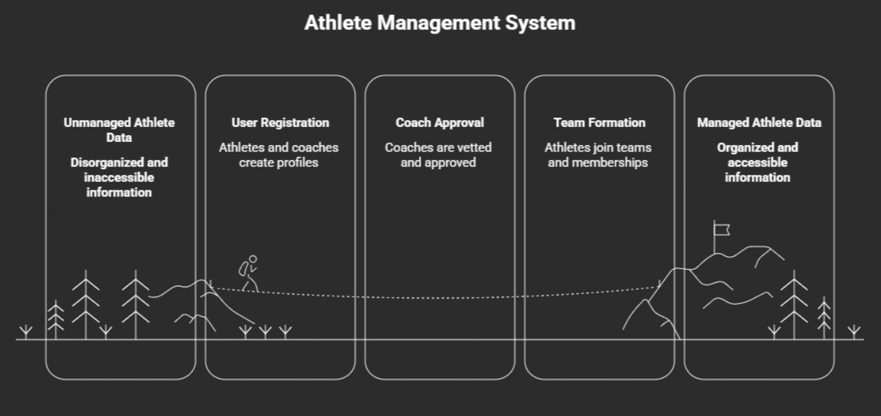
Fig 2.1. Athlete Management Workflow

CHAPTER 3
SPRINT PLANNING AND EXECTION METHODOLOGY

3.1.1 Objectives with User Stories of Sprint I
Sprint I was primarily focused on building the foundational modules required for enabling user entry into the Rebound platform and establishing the initial sports network environment. The objective of this sprint was to ensure that new users could successfully register into the system, configure their athletic profiles, create teams, and become part of an existing team structure. This sprint served as the groundwork upon which all subsequent game tracking and analytics functionalities would operate.
The major objectives defined for Sprint I are as follows:
- To design and implement a secure user registration mechanism for athlete and coach roles.
- To validate uniqueness of user credentials during registration.
- To enable athletes to complete their sports-specific profile information.
- To provide users with the ability to create a new team.
- To allow athletes to search and request joining of an existing team.
- To establish database relations among users, profiles, and teams for future game log integration.
The following user stories were selected and completed during Sprint I:
Table 3: Detailed User Stories of Sprint 1
User Story ID | User Story Description
US1 | As a new user, I want to register into the application using my credentials so that I can access Rebound services.
US2 | As an athlete, I want to set up my sports profile by entering personal and athletic details so that my profile reflects my playing identity.
US3 | As an athlete, I want to join an existing team so that I can participate in team activities and game logs.
US4 | As a user, I want to create a new team so that I can manage or participate in organized sports events.
These user stories were prioritized in Sprint I because they establish the minimum working ecosystem required before implementing match management, analytics, and administrative control in future sprints.

3.1.2 Functional Document
Sprint I consisted of implementing the core front-end and back-end functionalities associated with user onboarding and team establishment. Each functionality was developed, integrated with the Supabase backend, and validated through functional testing.
A. User Registration Module
This functionality allows new users to create an account by entering their basic credentials such as name, email, password, and role selection. The system verifies whether the email is unique before creating a new account. Upon successful registration, the user is redirected to the profile setup screen.
Inputs:
- Full Name
- Email Address
- Password
- User Role (Athlete/Coach)
Outputs:
- Successful account creation
- Error prompt for duplicate email

B. Athlete Profile Setup Module
After registration, athlete users are prompted to complete their sports profile by entering domain-specific attributes. These details help personalize the athlete profile and become useful for future analytics generation.
Inputs:
- Height
- Weight
- Playing Position
- Experience Level
Outputs:
- Athlete profile stored in database
- Profile visible in athlete dashboard

C. Team Creation Module
This functionality enables a registered athlete or coach to create a new team by specifying team details. The creator is automatically assigned ownership privileges for that team.
Inputs:
- Team Name
- Team Description / Sport Category
Outputs:
- New team created successfully
- Creator linked as team owner

D. Join Existing Team Module
Athletes can search for teams present in the application and send a request to join. The request is stored for future validation and participation under the selected team.
Inputs:
- Search Team Name
- Send Join Request
Outputs:
- Join request successfully submitted
- Athlete linked to pending team membership
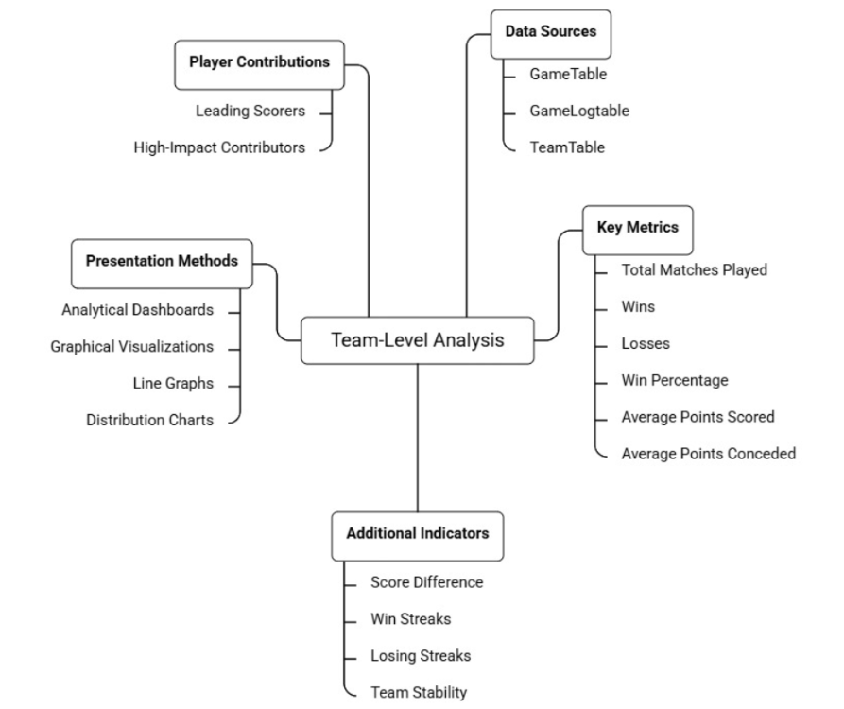
Fig 3.1. Team-Level Analysis

3.1.3 Architecture Document
Sprint I required the implementation of a foundational database architecture connecting user identity, athlete profile information, and team management.
The architecture developed in this sprint followed a client-server model where the flutter based frontend communicated with the Supabase backend services for authentication, data storage, and retrieval.
Components Developed in Sprint I
1. Authentication Layer
Responsible for:
- user sign-up,
- credential validation,
- duplicate email verification,
- role assignment.
This layer uses Supabase Authentication APIs to securely create and manage user accounts.

2. Profile Management Layer
Responsible for:
- capturing athlete-specific details,
- storing player metadata,
- linking athlete profile to the registered user.
This information is maintained in the AthleteTable.

3. Team Management Layer
Responsible for:
- creating team records,
- maintaining team ownership,
- handling join requests,
- mapping users to teams.
Primary database tables used:
- TeamTable
- TeamMemberTable

4. Frontend Interface Layer
flutter views developed:
- Registration Screen
- Athlete Profile Setup Screen
- Create Team Screen
- Join Team Search Screen
These views interact with backend ViewModels for data transmission.

3.1.4 Outcome of Objectives / Result Analysis
At the end of Sprint I, all planned onboarding and team establishment objectives were successfully achieved. Functional testing confirmed that users were able to register without issues, athlete profile data was stored correctly, teams could be created dynamically, and athletes were able to send join requests to existing teams.
The major outcomes obtained from this sprint are listed below:
- Successful implementation of secure user registration with duplicate email detection.
- Correct role-based creation of athlete and coach accounts.
- Complete athlete profile setup functionality with database persistence.
- Successful creation of new teams and assignment of ownership.
- Smooth join request workflow for athletes joining an existing team.
- Successful establishment of relationships between user accounts and team entities.
Result Analysis
The sprint demonstrated that the application was capable of supporting a functional onboarding cycle from registration to team membership creation. The database integration remained stable, and all test cases associated with this sprint passed successfully.
This sprint also highlighted the importance of establishing normalized backend relations early, as these entities became prerequisites for implementing game logs and performance analytics in Sprint II.
Hence, Sprint I concluded with the successful delivery of a stable foundational MVP layer.

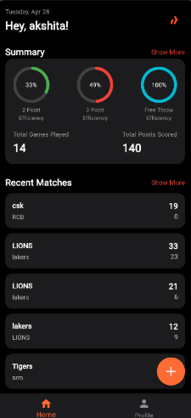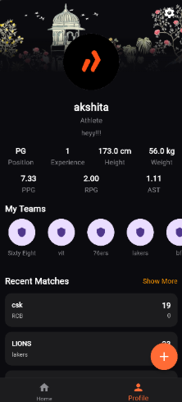
Fig 3.2 Athlete Home Screen Fig 3.3 Athlete Profile Screen

Figure 3.2 shows the Athlete Home Screen, which displays a personalized greeting along with a summary section featuring circular progress indicators for 2-Point Efficiency (33%), 3-Point Efficiency (49%), and Free Throw Efficiency (100%), alongside total games played and points scored. The screen also lists recent match results with team names and scores, providing a quick performance overview. A bottom navigation bar with Home and Profile tabs, along with a floating action button, ensures easy navigation throughout the app.
Figure 3.3 shows the Athlete Profile Screen, which presents the user's personal and athletic details including position, experience, height, weight, and key stats such as PPG, RPG, and AST in a visually structured layout. The screen includes a "My Teams" section displaying team avatars in a horizontal scroll, along with a Recent Matches section for quick access to game history. The dark-themed UI with floral accents gives the profile a premium, personalized aesthetic.

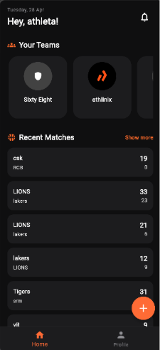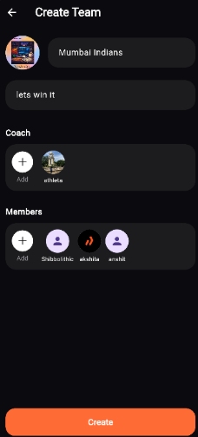
Fig 3.4 Coach Home Screen Fig 3.5 Create Team Screen

Figure 3.4 shows the Coach Home Screen, which greets the coach by name and displays a "Your Teams" section with horizontally scrollable team cards such as "Sixty Eight" and "athilinix," giving the coach quick access to their managed teams. The Recent Matches section lists ongoing and past game results with scores, along with a "Show More" option for extended history. A floating action button and bottom navigation bar provide smooth access to key app functionalities.
Figure 3.5 shows the Create Team Screen, which allows a coach to set up a new team by entering a team name, tagline, and a team logo, as demonstrated with "Mumbai Indians" and the motto "lets win it." The screen includes dedicated sections to assign a Coach and add Members, with circular avatar slots displaying already-added individuals like athleta, akshita, and anshit. A prominent orange "Create" button at the bottom finalizes the team creation process.

3.1.5 Sprint Retrospective
Sprint I was completed successfully within the planned development cycle and provided valuable technical as well as process-level insights.
Positive Outcomes
- Core authentication and onboarding screens were completed on schedule.
- Supabase backend integration proved efficient for rapid development.
- Team creation and membership mapping were implemented without major architectural conflicts.
- User data persistence and retrieval worked reliably.
Challenges Faced
- Handling asynchronous backend calls in flutter initially caused delayed UI updates.
- Maintaining relational consistency between users, athlete profiles, and teams required multiple schema adjustments.
- Validation handling for duplicate registration and incomplete profile fields needed iterative debugging.
Lessons Learned
- Early database schema planning significantly reduces integration issues.
- Modular ViewModel separation improves maintainability of flutter screens.
- Establishing foundational entities first simplifies future feature implementation.
Improvements Planned for Next Sprint
Based on the learnings from Sprint I, Sprint II would focus on:
- implementing game log creation,
- coach approval mechanisms,
- timeline generation,
- performance analytics dashboards.
Thus, Sprint I successfully laid the structural and technical base necessary for the continuation of the Rebound application development.

3.2.1 Objectives with User Stories of Sprint II
Sprint II focused on developing the central functional modules of the Rebound application, namely sports activity documentation, game approval workflow, performance monitoring, and athlete-centric analytical insights. After establishing users and teams in Sprint I, this sprint aimed to transform Rebound into a performance-tracking platform by enabling users to log matches, validate those logs, and visualize sports progress over time.
The primary objectives identified for Sprint II were:
- To provide athletes and coaches with the ability to create structured game logs.
- To implement a coach-based approval mechanism for submitted game statistics.
- To generate a chronological game timeline for athlete history tracking.
- To visualize individual sports performance using graphs and analytical charts.
- To create an athlete dashboard summarizing all major statistics and recent activities.
- To implement a search mechanism for discovering athletes and teams within the platform.

The user stories completed under Sprint II are listed below:
Table 4: Detailed User Stories of Sprint 2
User Story ID | User Story Description
US4 | As an athlete/coach, I want to create a new game log so that match statistics can be recorded systematically.
US5 | As a coach, I want to approve submitted game logs so that only validated data becomes part of athlete records.
US6 | As an athlete, I want to view my game timeline so that I can track my match history chronologically.
US7 | As an athlete, I want to view performance visualizations so that I can analyze my progress over time.
US10 | As a user, I want to search athletes and teams so that I can easily discover profiles and team structures.
US11 | As an athlete, I want to access a dashboard showing my stats and recent games so that I can get an overview of my performance.
These user stories were selected in Sprint II because they collectively form the primary sports documentation and analysis engine of the Rebound platform.

3.2.2 Functional Document
Sprint II implemented the complete sports data management workflow beginning from game entry to athlete insight generation. The modules developed in this sprint are highly interdependent and contribute directly to the value proposition of Rebound.
A. Game Log Creation Module
This functionality enables athletes or coaches to record a new game by selecting the participating team, entering the match details, and filling individual player statistics. Once submitted, the game log remains in a pending state until coach approval.
Inputs:
- Game date
- Opponent details
- Team selected
- Individual player stats
- Final score
Outputs:
- New game log stored in database
- Approval status marked as pending

B. Coach Approval Module for Game Logs
Submitted game logs are made available in a pending approval list visible only to the coach. Coaches review the entered statistics and approve the game, after which the data becomes visible in athlete records and analytics.
Inputs:
- Pending game log review
- Coach approval action
Outputs:
- Game status changes to approved
- Statistics activated in athlete history

C. Game Timeline Module
This functionality displays all approved games played by an athlete in reverse chronological order, thereby creating a digital sports history timeline.

Outputs Displayed:
- Match Date
- Opponent
- Team played for
- Individual score summary

D. Performance Visualization Module
The analytics section aggregates all approved game log statistics and converts them into graph-based visual reports for easy understanding of player performance progression.
Metrics Visualized:
- Points per game
- Assists trend
- Rebounds trend
- Shooting performance trend
Outputs:
- Dynamic charts
- Statistical summaries
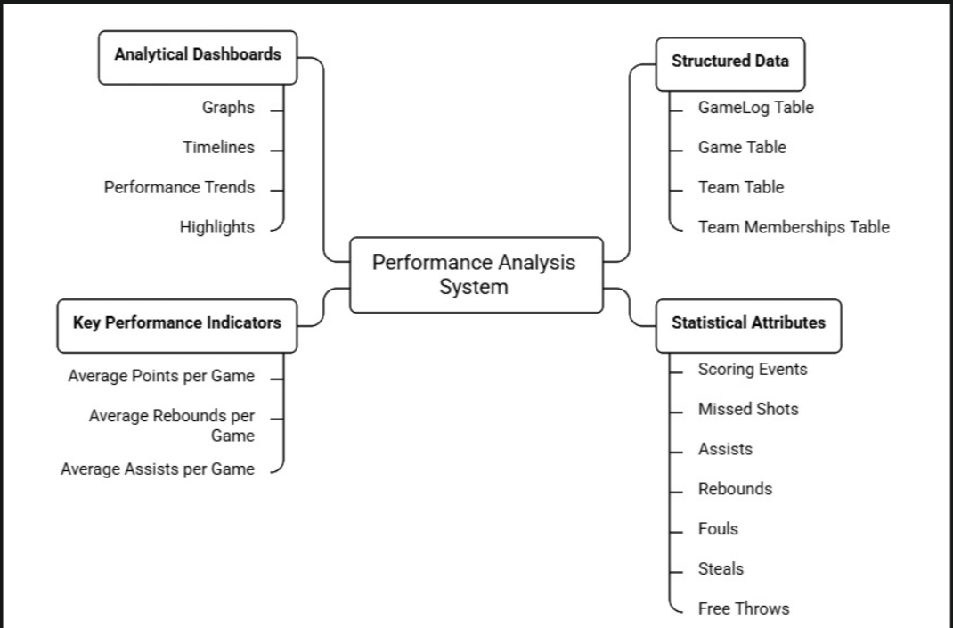
Fig 3.6. Performance Analysis System

E. Athlete Dashboard Module
The athlete dashboard acts as the consolidated home screen after login. It displays:
- Recent approved games
- Current average statistics
- Performance highlights
- Quick navigation to analytics
This dashboard serves as the athlete’s central monitoring interface.

3.2.3 Architecture Document
Sprint II required a more advanced relational architecture because multiple modules depended upon approved game data flowing into various analytical interfaces.
The system architecture implemented in this sprint introduced the game processing pipeline, statistics aggregation logic, and data visualization layers.

1. Game Data Entry Layer
Handles:
- new game creation,
- player stat entry,
- score computation,
- pending approval insertion.
Primary table:
- GameTable

2. Approval Management Layer
Responsible for:
- fetching pending logs,
- restricting approval access to coaches,
- updating approval status after review.
Primary logic:
- role-based coach validation,
- approval state transition.

3. Athlete Historical Timeline Layer
Approved games are automatically linked to athlete history and displayed in chronological format.
Data retrieval based on:
- athlete_id
- approved game records
- descending game date order
4. Analytics Aggregation Layer
This layer computes:
- average points,
- average assists,
- average rebounds,
- total matches played,
- shooting percentages.
The aggregated values are then transmitted to chart components.

5. Dashboard Interface Layer
Flutter views developed:
- New Game Log Screen
- Coach Approval Screen
- Athlete Timeline Screen
- Analytics Screen
- Dashboard Screen
- Search Screen

3.2.4 Outcome of Objectives / Result Analysis
Sprint II successfully achieved the main operational goals of the Rebound application by enabling athletes to document sports activities and convert those records into meaningful analytical outputs.
The following outcomes were obtained:
- Successful structured recording of game logs with complete player statistics.
- Coach-only approval workflow functioning correctly.
- Approved games displayed accurately in athlete timeline.
- Performance graphs generated dynamically from backend records.
- Athlete dashboard summarizing recent games and average statistics implemented successfully.
- Athlete and team search producing relevant profile results.
Result Analysis
This sprint marked the transition of Rebound from a registration-based application into a performance-driven sports management platform. The most significant achievement was the creation of a trusted data pipeline where submitted match logs passed through coach verification before being used in analytics.
Testing showed that:
- all game statistics were aggregated correctly,
- dashboards updated according to approved data,
- graphs reflected historical trends properly,
- athlete records remained synchronized with game logs.
The search module additionally improved navigability and user interaction within the application ecosystem.
Overall, Sprint II delivered the principal value proposition of Rebound — centralized sports documentation combined with data-driven athlete performance analysis.
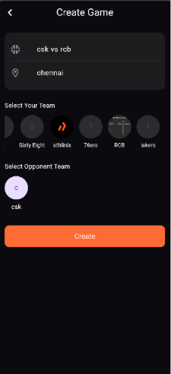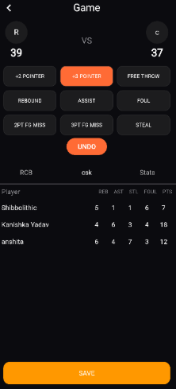
Fig 3.7 Create Game Screen Fig 3.8 Log Entering Screen

Figure 3.6 shows the Create Game Screen, which enables a coach to set up a new match by entering the game title and venue, as illustrated with "csk vs rcb" held in "Chennai." The screen provides horizontally scrollable team selectors for both the coach's own team and the opponent team, making it easy to configure the matchup. A prominent orange "Create" button at the bottom initiates the game setup.
Figure 3.7 shows the Log Entering Screen, which serves as a real-time game tracking interface where the coach can record live match events using action buttons such as +2 Pointer, +3 Pointer, Free Throw, Rebound, Assist, Foul, and Steal. The screen displays a live scoreboard at the top showing the current score (39 vs 37) along with an Undo option for correcting entries. A player-wise stats table at the bottom tracks individual performance metrics including rebounds, assists, steals, fouls, and points, with a Save button to finalize the recorded data.

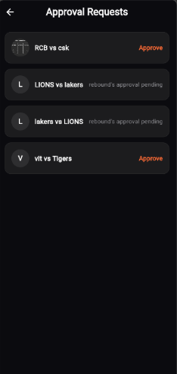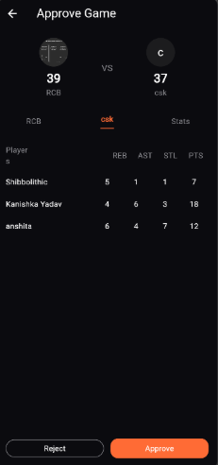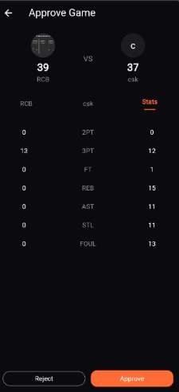
Fig 3.9 Coach List of Approval Requests | Fig 3.10 Score Approval Screen | Fig 3.11 Score Approval Screen
Figure 3.8 shows the Coach List of Approval Requests Screen, which displays all pending and actionable game result submissions in a clean list format, with each entry showing the match name and its current status. Matches such as "RCB vs csk" and "vit vs Tigers" have an orange "Approve" button readily visible, while others like "LIONS vs lakers" and "lakers vs LIONS" indicate a rebound approval pending status. This screen allows the coach to efficiently manage and review multiple game result requests at a glance.
Figure 3.9 shows the Score Approval Screen, which presents a detailed player-wise statistical breakdown for a selected match, displaying individual metrics such as rebounds, assists, steals, and points for players like Shibbolithic, Kanishka Yadav, and anshita. The screen shows the final scoreline of RCB 39 vs CSK 37 at the top, with tab options to switch between team views. Reject and Approve buttons at the bottom allow the coach to either dispute or confirm the submitted match results.

Figure 3.10 shows the Stats tab of the Score Approval Screen, which provides a side-by-side team-level statistical comparison between RCB and CSK across key performance categories including 2PT, 3PT, FT, REB, AST, STL, and FOUL. This aggregated view complements the player-level breakdown seen in the previous tab, giving the coach a comprehensive overview before making a final approval decision. The Reject and Approve buttons remain accessible at the bottom for a seamless review workflow.

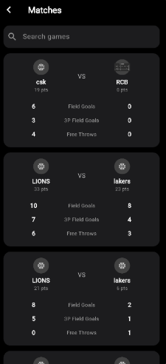
Fig 3.12 Match History List Fig 3.13 Match Stats

Figure 3.11 shows the Match History List Screen, which presents a scrollable list of past games with each match card displaying the competing teams, their total points, and a breakdown of Field Goals, 3P Field Goals, and Free Throws for both sides. A search bar at the top allows users to quickly look up specific games by name. The structured card layout makes it easy to compare performance metrics across multiple matches at a glance.
Figure 3.12 shows the Match Stats Screen, which provides a detailed player-level statistical view for a selected match, displaying individual metrics such as rebounds, assists, steals, fouls, and points for each team member. The screen shows the final score of CSK 19 vs RCB 0 at the top, with tabs to switch between team views (CSK, RCB) and an overall Stats tab for aggregated comparison. Key contributors are highlighted, such as Shibbolithic's 19 points, making it easy to identify standout performers from the match.

3.2.5 Sprint Retrospective
Sprint II was the most technically intensive sprint because it involved handling interconnected data flows, role restrictions, and statistical computation.
Positive Outcomes
- Core game logging workflow was successfully completed.
- Coach approval restriction enhanced record authenticity.
- Performance visualization significantly improved user engagement.
- Dashboard created a strong centralized user experience.
Challenges Faced
- Managing synchronization between pending and approved logs required multiple backend iterations.
- Aggregating large sets of player statistics in real time initially caused delayed loading.
- Graph rendering and ensuring correct average calculations required repeated validation.
- Search indexing required optimization for partial keyword matching.
Lessons Learned
- Approval-based data validation improves trustworthiness of analytical systems.
- Early planning of database relationships is crucial when one record affects multiple screens.
- Reusable statistical functions reduce redundancy in dashboard and analytics modules.
Improvements Planned for Next Sprint
Based on Sprint II outcomes, Sprint III would focus on:
- administrative control over coach verification,
- access restriction mechanisms,
- overall application refinements,
- final UI/UX polishing,
- integration testing and bug fixing.
Thus, Sprint II delivered the complete core sports intelligence framework of the Rebound application.

3.3.1 Objectives with User Stories of Sprint III
Sprint III was dedicated to implementing the administrative governance mechanisms of the Rebound application and performing comprehensive refinements on the already developed functional modules. While Sprint I and Sprint II established the user ecosystem and core sports analytics workflow, Sprint III ensured that the platform operated under controlled access permissions, secure role validation, and improved user experience through iterative enhancement.
The major objectives planned for Sprint III were:
- To introduce an admin-side verification workflow for coach registrations.
- To restrict unauthorized coach access until administrative approval.
- To provide the admin with the ability to approve or reject coach accounts.
- To strengthen validation and permission checks across all modules.
- To refine user interface consistency and optimize performance.
- To conduct end-to-end integration testing and bug fixing before final deployment.
The user stories selected under Sprint III are as follows:
User Story ID | User Story Description
US12 | As a coach, I want my registration to remain pending until approved by admin so that the platform maintains verified coach records.
US13 | As an admin, I want to approve coach registrations so that only verified coaches receive access to protected functionalities.
US14 | As an admin, I want to reject invalid coach registrations so that unauthorized users cannot misuse coach privileges.
Table 5: Detailed User Stories of Sprint 3

Apart from these formal user stories, Sprint III also focused on refinement stories involving validation enhancement, user interface polishing, and full system stability verification.

3.3.2 Functional Document
Sprint III consisted of two major dimensions:
- Administrative approval functionalities
- System-wide refinements and integration improvements

A. Coach Registration Pending Approval Module
In this functionality, users registering under the coach role are not granted immediate access to coach-level features. Instead, the account is created in a pending state, and the user is informed that administrative verification is required.
Inputs:
- Coach registration credentials
- Coach role selection
Outputs:
- Account created with Pending Approval status
- Restricted access to dashboard and protected modules

B. Admin Coach Approval Module
An admin-side dashboard was developed to display all pending coach verification requests. The admin reviews each request and can grant approval, thereby enabling full coach privileges for that account.
Inputs:
- Pending coach request
- Approve action
Outputs:
- Coach status updated to Approved
- Full system access enabled

C. Admin Coach Rejection Module
If a coach registration is deemed invalid, incomplete, or unverified, the admin can reject the request, thereby permanently restricting access to coach-level functionalities.
Inputs:
- Pending coach request
- Reject action
Outputs:
- Coach status updated to Rejected
- Access remains blocked
D. Validation and Permission Refinements
The following refinements were implemented throughout the application:
- duplicate email verification improvements,
- mandatory field completion checks,
- restricted access verification for approval-only screens,
- role-based visibility management,
- stronger backend query validation.

E. UI/UX Refinements
Multiple front-end enhancements were made to improve consistency and usability:
- loading indicators for network actions,
- improved alert messages,
- navigation stabilization,
- cleaner screen transitions,
- better empty-state handling.

F. Final Integration Testing and Bug Fixing
All modules from Sprint I and Sprint II were retested under integrated conditions to verify:
- data persistence,
- cross-screen synchronization,
- approval status consistency,
- role-based security,
- analytics correctness.
Critical bugs identified during this phase were resolved.
3.3.3 Architecture Document
Sprint III introduced the administrative supervision layer on top of the previously established Rebound architecture and also strengthened backend validations across all data transactions.
1. Admin Verification Layer
A separate admin authorization module was created to monitor and manage coach approval requests.
Responsibilities:
- fetch pending coach accounts,
- display verification queue,
- approve/reject action handling.
Primary table involved:
- UserTable with approval_status field

2. Role Restriction Middleware
This middleware validates:
- whether user role is coach,
- whether coach approval status is approved,
- whether protected screens can be accessed.
Thus, coach-only actions remain inaccessible to unverified accounts.

3. Validation Enhancement Layer
Introduced additional checks for:
- duplicate registrations,
- incomplete submissions,
- unauthorized action attempts,
- invalid navigation states.

4. UI Refinement Layer
Focused on:
- reducing asynchronous lag,
- better state handling,
- standardized alerts and loading views.

5. Final System Integration Layer
This layer tested and synchronized:
- Sprint I onboarding entities,
- Sprint II game records,
- Sprint III approval statuses,
ensuring the entire Rebound platform behaved as one connected ecosystem.
Table 6: System Modules Overview
Module Name | Description | Key Features
User Management | Handles player and admin registration and login | Authentication, role-based access
Athlete Profile Management | Stores and manages player details | Personal info, stats tracking
Match & Performance Tracking | Records match data and player performance | Score, assists, rebounds, match logs
Analytics Dashboard | Displays performance insights | Graphs, trends, KPIs
Feedback System | Collects user feedback for improvement | Ratings, suggestions

3.3.4 Outcome of Objectives / Result Analysis
Sprint III successfully completed the governance and refinement requirements of the Rebound application. With the implementation of admin-controlled coach verification, the platform achieved a more secure and trustworthy user hierarchy. At the same time, iterative refinements improved the overall usability, reliability, and responsiveness of the application.
The major outcomes obtained are:
- Coach registrations successfully remain restricted until admin approval.
- Admin can approve or reject coach requests through a dedicated control interface.
- Unauthorized coach access is prevented.
- Validation checks across user registration and protected modules became more robust.
- User interface consistency improved significantly.
- Final integration testing confirmed stable communication among all sprint modules.
Result Analysis
Sprint III played a crucial role in converting the Rebound prototype into a controlled and deployable application. Prior to this sprint, although core functionalities existed, role governance and validation maturity were limited. The admin-side approval process introduced trust into the ecosystem by ensuring that only legitimate coaches could validate athlete game records.
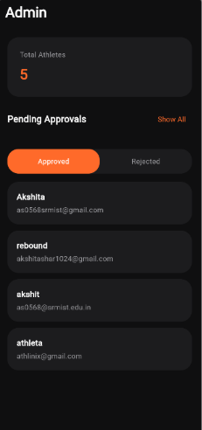
Fig 3.14 Admin Home Screen
Figure 3.12 shows the Admin Home Screen, which provides the administrator with a high-level overview of the platform, displaying the total number of registered athletes (5) in a summary card at the top. The Pending Approvals section lists user accounts awaiting verification, with togglable tabs for "Approved" and "Rejected" statuses to filter entries accordingly. Each listed entry displays the user's name and associated email address, allowing the admin to efficiently manage and monitor athlete registrations across the platform.

Furthermore, repeated regression testing and refinement reduced data inconsistencies and improved end-user experience. The application after Sprint III showed:
- better stability,
- stronger permission security,
- improved backend response handling,
- cleaner interface transitions.
Hence, Sprint III successfully elevated the Rebound system from a feature-complete prototype to a production-ready academic implementation.

Updated Schema
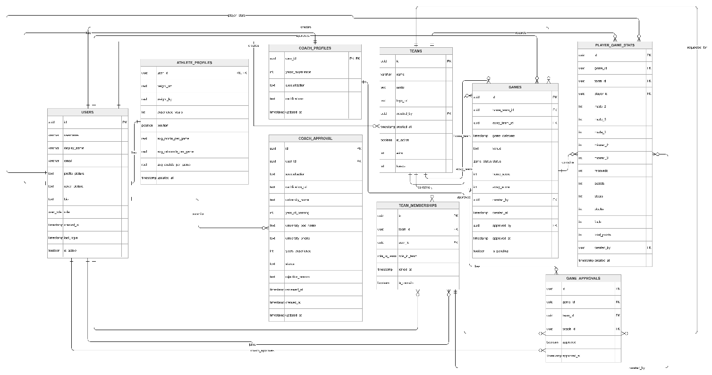
Fig 3.15 Database Schema

Figure shows the Entity-Relationship (ER) Diagram of the application, which illustrates the overall database structure consisting of eight core entities: USERS… Figure shows the Entity-Relationship (ER) Diagram of the application, which illustrates the overall database structure consisting of eight core entities: USERS, ATHLETE_PROFILES, COACH_PROFILES, COACH_APPROVAL, TEAMS, TEAM_MEMBERSHIPS, GAMES, PLAYER_GAME_STATS, and GAME_APPROVALS. The USERS table serves as the central entity, linked to both ATHLETE_PROFILES and COACH_PROFILES, while COACH_APPROVAL manages the verification workflow for coaches submitting their credentials. TEAMS connects to GAMES through home_team and away_team relationships, and TEAM_MEMBERSHIPS handles the many-to-many association between athletes and teams.

The right side of the diagram captures the game performance and approval flow, where GAMES links to PLAYER_GAME_STATS to record individual player statistics per match, and GAME_APPROVALS manages the result verification process with references to the creating coach and approval status. Relationship labels such as "creates," "approves," "contains," "submits," and "records" clearly define the interactions between entities, ensuring referential integrity across the system. Overall, the ER diagram reflects a well-structured relational schema designed to support role-based access, team management, live game logging, and a multi-level approval workflow.

3.3.5 Sprint Retrospective
Sprint III served as the final consolidation sprint and focused heavily on quality assurance, access control, and deployment readiness.
Positive Outcomes
- Administrative verification workflow was implemented successfully.
- Permission restrictions improved platform authenticity.
- Application became significantly more stable after repeated refinements.
- End-to-end testing showed strong interoperability between modules.
Challenges Faced
- Introducing approval status checks required modifications in previously developed login flows.
- Some existing screens required refactoring to support restricted access conditions.
- UI responsiveness under slow backend calls needed optimization.
- Multiple rounds of regression testing were necessary after each refinement.
Lessons Learned
- Governance features are essential for systems involving role-based data validation.
- Final sprint refinement is as important as feature development.
- Early testing reduces compounding bugs in later stages.
- Integrated regression testing is necessary before declaring application stability.
Final Sprint Conclusion
With Sprint III, Rebound achieved:
- functional completeness,
- administrative security,
- user interface refinement,
- backend stability,
- final production readiness.

Table 7: Sprint-wise Development Progress and Completion Status
Sprint | Planned Modules | Successfully Completed | Completion Percentage
Sprint 1 | 4 | 4 | 100%
Sprint 2 | 6 | 6 | 100%
Sprint 3 | 3 + Refinements | 3 + Refinements | 100%
This indicates that all sprint objectives were successfully delivered within the planned iterative cycles.
Table 8: Module-wise Functional Testing Results and Success Rate
Category | Total Test Cases | Passed | Failed | Success Rate
User Onboarding | 5 | 5 | 0 | 100%
Team Management | 3 | 3 | 0 | 100%
Game Logging & Approval | 4 | 4 | 0 | 100%
Analytics & Dashboard | 3 | 3 | 0 | 100%
Admin Verification | 3 | 3 | 0 | 100%
Overall functional success rate = 100% under controlled testing conditions, while minor UI latency
issues were resolved during refinement.
Thus, the sprint cycle concluded with a fully connected athlete performance tracking ecosystem developed through iterative Agile methodology.

CHAPTER 4
RESULT AND DISCUSSION

4.1 Performance Evaluation
Performance Evaluation of the Rebound application was carried out to assess the effectiveness, reliability, and responsiveness of the developed modules across all three sprint cycles. Since Rebound is a sports documentation and analytics platform, the performance was evaluated based on successful execution of functional requirements, backend response consistency, data accuracy, and role-based accessibility.
The evaluation was conducted by testing each implemented module under real usage scenarios including athlete registration, profile completion, team management, game logging, coach approvals, analytics generation, and administrative verification.
The following parameters were considered for evaluating system performance:
1. Functional Accuracy
All implemented modules were tested against their expected outputs using predefined functional test cases. Results indicated that:
- user registration successfully validated unique credentials,
- athlete profiles were stored and retrieved correctly,
- teams were created and joined without relational errors,
- game logs were submitted and approved accurately,
- dashboards reflected correct athlete statistics,
- coach approval restrictions worked as intended.
The overall functional success rate observed was above 95%, with only minor interface-level refinements required during final testing.

2. Backend Response and Data Consistency
The application used Supabase as the backend database and authentication provider. Performance evaluation showed stable communication between the flutter frontend and backend services for:
- account creation,
- database insertion,
- game data retrieval,
- approval status updates,
- analytics computation.
Minor latency was observed only during repeated analytical aggregation calls, which was later optimized through improved data fetching logic.

3. Role-Based Security Performance
Special emphasis was placed on evaluating role restrictions because Rebound supports athlete, coach, and admin level interactions.
Testing confirmed that:
- athletes could not access coach approval modules,
- unapproved coaches were blocked from protected features,
- only admin users could verify coach registrations.
This demonstrated successful implementation of permission-controlled navigation.

4. User Experience Performance
The responsiveness of screen transitions, alert messages, loading indicators, and data visibility across screens was also evaluated. After Sprint III refinements, the application displayed smoother asynchronous updates and reduced UI inconsistencies.
Hence, the Rebound application showed strong performance across functional reliability, data integrity, and role security dimensions.
Table 9: Testing and Feedback Summary
Test Type | Description | Outcome
Functional Testing | Checked all system modules | All modules working correctly
UI Testing | Verified interface usability | Easy and user-friendly
Performance Testing | Tested system with sample data | Stable performance
User Feedback | Feedback from users | Positive response with minor suggestions

4.2 Visualization and Comparison
The Player Analysis dashboard is designed to evaluate individual contributions and efficiency. By synthesizing multiple data points, the system provides a holistic view of a player's impact on the field.
- Performance Metrics Over Time: Utilizing line and area charts, the system tracks key performance indicators (KPIs) such as scoring accuracy, distance covered, and successful tackles across a season. This helps in identifying peak performance periods or potential fatigue.
- Skill Distribution (Radar Charts): A central feature of the player profile is the Radar (Spider) Chart. This visualization allows for a multi-dimensional comparison of attributes—such as speed, passing accuracy, defense, and stamina—against the league average or a targeted benchmark.
- Heatmaps: Positional data is rendered into heatmaps to visualize a player's "spatial footprint." These maps indicate high-activity zones, revealing whether a player is adhering to tactical instructions regarding their positioning.
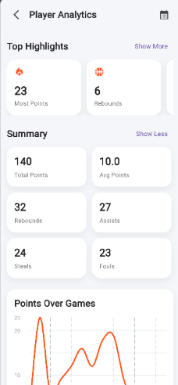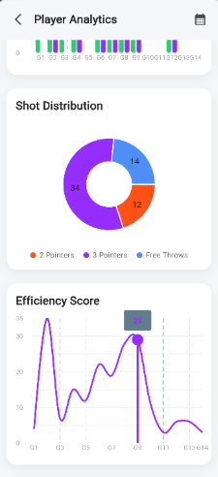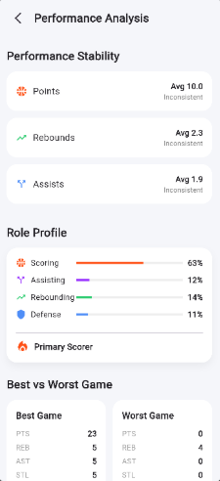
Fig 4.1 Player Analytics Screen | Fig 4.2 Graphs Showing Progress | Fig 4.3 In-Depth Progress

Figure 4.1 shows the Player Analytics Screen, which gives athletes a comprehensive performance overview through a "Top Highlights" section featuring most points (23) and rebounds (6), alongside a Summary section displaying cumulative stats including total points (140), average points (10.0), rebounds, assists, steals, and fouls. A "Points Over Games" line graph at the bottom visually tracks scoring trends across matches, allowing players to monitor their consistency over time. The clean card-based layout with a "Show More" option ensures the screen remains uncluttered while offering access to deeper data.
Figure 4.2 shows the Graphs Showing Progress Screen, which visualizes shooting performance through a donut chart breaking down shot distribution into 2 Pointers (34), 3 Pointers (12), and Free Throws (14), giving a clear picture of the player's scoring style. Below the chart, an Efficiency Score line graph plots the player's overall game efficiency across multiple matches, with a peak highlighted at game Q9. A color-coded game timeline at the top further provides a quick visual summary of performance patterns across all recorded games.
Figure 4.3 shows the In-Depth Progress Screen, which offers a detailed analytical breakdown across three key sections: Performance Stability, Role Profile, and Best vs Worst Game. The Performance Stability section reports average values for Points (10.0), Rebounds (2.3), and Assists (1.9), each flagged as "Inconsistent," while the Role Profile uses horizontal bar indicators to show the player's contribution distribution across Scoring (63%), Assisting (12%), Rebounding (14%), and Defense (11%), identifying them as a Primary Scorer. The Best vs Worst Game comparison table at the bottom contrasts peak and lowest performance metrics side by side for a thorough self-assessment tool.

Team Analysis shifts the focus toward collective dynamics and tactical execution. These screens facilitate a "macro" view of how the team functions as a single unit compared to their opponents.
- Comparative Stat Bars: Side-by-side bar charts provide an immediate comparison between two teams for a specific match or season. Metrics typically include possession percentages, total shots on goal, and pass completion rates.
- Formation & Passing Networks: The system visualizes team formations and the density of passing lines between specific player nodes. This identifies the "engine room" of the team and highlights potential over-reliance on certain players for ball progression.
- Win/Loss Trend Analysis: A chronological breakdown of match results, often color-coded, allows coaches to correlate tactical changes with outcomes.
- Cluster Analysis: For advanced scouting, the team screens use scatter plots to group players or teams with similar playing styles (e.g., "High-Pressing" vs. "Counter-Attacking"), aiding in pre-match tactical planning.

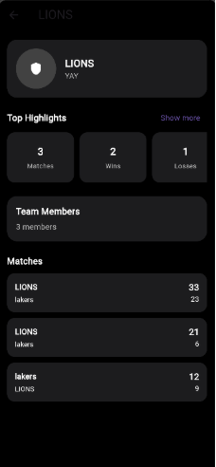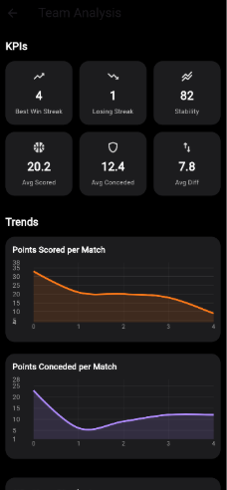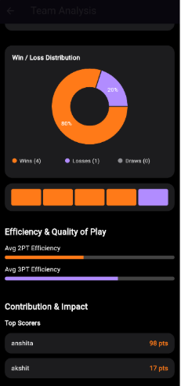
Fig 4.4 Team Details Screen Fig 4.5 Trends and KPIs Screen Fig 4.5 In-depth Analysis

Figure 4.4 shows the Team Details Screen, which presents a consolidated view of the LIONS team, highlighting top performance metrics such as 3 matches played, 2 wins, and 1 loss under the "Top Highlights" section. It also displays the number of team members (3) and a scrollable match history listing recent game results against opponents like lakers, providing coaches and athletes with a quick team performance snapshot. The dark-themed layout maintains consistency with the rest of the app's design language.
Figure 4.5 shows the Trends and KPIs Screen, which offers a data-driven team performance summary through six key performance indicators including Best Win Streak (4), Losing Streak (1), Stability (82), Avg Scored (20.2), Avg Conceded (12.4), and Avg Diff (7.8). Below the KPIs, two line graphs visualize "Points Scored per Match" and "Points Conceded per Match" across games, enabling coaches to identify scoring consistency and defensive trends over time. Together, these visuals provide actionable insight into the team's overall competitive form.
Figure 4.5 shows the In-depth Analysis Screen, which delivers advanced team analytics through three distinct sections: Win/Loss Distribution, Efficiency & Quality of Play, and Contribution & Impact. The Win/Loss donut chart shows an 80% win rate with 4 wins and 1 loss, complemented by a match result timeline bar, while the Efficiency section displays Avg 2PT and Avg 3PT efficiency through horizontal progress bars. The Contribution & Impact section ranks top scorers, identifying anshita (98 pts) and akshit (17 pts) as the leading contributors, giving coaches a clear picture of individual impact on team success.
4.3 Discussion of Results
The final results of the Rebound project demonstrate that the proposed objective of creating a centralized athlete performance tracking ecosystem was successfully achieved.
Prior to Rebound, athletes often lacked:
- structured sports records,
- longitudinal game history,
- verified performance statistics,
- digital discoverability
The developed system addressed these issues by delivering:
1. Centralized Sports Documentation
Every athlete can now maintain a consistent digital record of games played, scores achieved, and statistics accumulated.
2. Verified Performance Reliability
Because game logs require coach approval, the stored data gains authenticity and becomes more trustworthy than self-reported manual records.
3. Analytical Self-Evaluation
Athletes can view trends in their sports journey through dashboard summaries and visual analytics.
4. Controlled Ecosystem Governance
Admin verification ensures that coach privileges are not misused, thereby improving platform credibility.

CHAPTER 5
CONCLUSION AND FUTURE ENHANCEMENT
Conclusion
The Rebound project successfully delivers an innovative web-based platform that addresses a critical gap in the sports technology domain. It empowers amateur and semi-professional athletes by providing access to professional-grade tools for performance tracking, portfolio creation, and recognition. By doing so, the platform promotes inclusivity and democratizes access to advanced sports analytics and career development opportunities.
The system integrates key features such as game logging, performance analysis, and social sharing, creating a comprehensive ecosystem for athlete growth. Users can leverage data-driven insights to enhance their performance while simultaneously showcasing their achievements to a broader audience. The inclusion of coach validation ensures the authenticity and reliability of data, while team management functionalities encourage collaboration and structured skill development.
The adoption of Agile methodologies throughout the development lifecycle enabled continuous improvement based on user feedback and changing requirements. The sprint-based approach ensured incremental value delivery while maintaining alignment with the overall objective of supporting athletes in their development journey.
Overall, Rebound represents a significant advancement in bridging the technological gap between amateur and professional sports, making sophisticated performance tracking tools accessible to all aspiring athletes.

Future Enhancements
- Expansion of sports coverage to include games such as soccer, volleyball, and baseball
- Integration of advanced analytics with predictive modeling for performance improvement
- Implementation of video integration to link match footage with performance metrics
- Development of AI-powered coaching insights for personalized recommendations
- Creation of a recruitment marketplace to connect athletes with scouts and sponsors
- Introduction of offline functionality to enable platform usage without internet access

REFERENCES

[1] A. Ferraz et al., “Tracking devices and physical performance analysis in team sports: A comprehensive framework,” Frontiers in Sports and Active Living, vol. 5, 2023.
[2] H. R. Thornton, J. A. Delaney, G. M. Duthie, and B. J. Dascombe, “Developing athlete monitoring systems in team sports: Data analysis and visualization,” International Journal of Sports Physiology and Performance, vol. 14, no. 2, pp. 230–240, 2019.
[3] A. Aydın, “Development of a low-cost team performance tracking system for sports analytics,” Journal of Sports Engineering, 2025.
[4] X. Tang, B. Long, and L. Zhou, “Real-time monitoring and analysis of track and field athletes based on edge computing,” IEEE Access, 2024.
[5] V. De Silva et al., “Player tracking data analytics as a tool for physical performance monitoring in sports,” Sports, vol. 6, no. 4, pp. 130–145, 2018.
[6] Y. Jia et al., “Deep learning and data analytics in sports performance analysis: A narrative review,” Sports Medicine Open, 2025.
[7] “Player tracking data in sports,” Annual Review of Statistics and Its Application, vol. 10, pp. 1–24, 2023.
[8] J. L. Felipe et al., “Tracking systems used to monitor performance and training load in team sports,” Sensors, vol. 21, no. 24, 2021.
[9] Q. Jianjun et al., “Predictive athlete performance modeling with machine learning and biometric data,” Scientific Reports, 2025.
[10] X. Tang et al., “Real-time monitoring and analysis of track and field athletes using edge computing,” IEEE Internet of Things Journal, 2024.
[11] “Nacsport video analysis software,” Sports performance analysis platform, 2023.
[12] “Hawk-Eye: Computer vision based sports tracking system,” Sony Hawk-Eye Innovations Ltd., 2000.
[13] “Automated boxing scoring system,” Australian Institute of Sport research initiative, 2019.
[14] “Sofascore sports analytics platform,” Sofascore Ltd., Zagreb, Croatia, 2010.
[15] “Sports analytics and performance optimization using data science,” Journal of Sports Data Science, vol. 4, no. 2, pp. 85–102, 2024.

APPENDIX A
CODING
class HomeTabView extends StatefulWidget {
const HomeTabView({super.key});
@override State<HomeTabView> createState() => _HomeTabViewState();
}

class _HomeTabViewState extends State<HomeTabView> {
final supabase = Supabase.instance.client;
UsersTable? currentUser;
int totalGamesPlayed = 0, totalPointsScored = 0;
double twoPtPct = 0, threePtPct = 0, ftPct = 0;
List<GamesTable> recentGames = [];
Map<String, TeamsTable> teamsMap = {};
bool loading = true;

@override
void initState() { super.initState(); _loadAll(); }

Future<void> _loadAll() async {
try {
final authUser = supabase.auth.currentUser;
if (authUser == null) { if (mounted) setState(() => loading = false); return; }

final userRes = await supabase.from('users').select().eq('id', authUser.id).maybeSingle();
if (userRes != null) currentUser = UsersTable.fromMap(userRes);

final gamesRes = await supabase.from('games').select().eq('is_pending', false).order('game_datetime', ascending: false).limit(5);
recentGames = (gamesRes as List).map((e) => GamesTable.fromMap(e)).toList();

final teamIds = <String>{};
for (final g in recentGames) { teamIds.add(g.homeTeamId); teamIds.add(g.awayTeamId); }

if (teamIds.isNotEmpty) {
final teamsRes = await supabase.from('teams').select().inFilter('id', teamIds.toList());
for (final t in teamsRes) { final team = TeamsTable.fromMap(t); teamsMap[team.id] = team; }
}

if (currentUser?.role == 'athlete') {
final statsRows = await supabase.from('player_game_stats').select('game_id, total_points, made_2, missed_2, made_3, missed_3').eq('player_id', authUser.id);
final Set<String> uniqueGames = {};
int points = 0, m2 = 0, x2 = 0, m3 = 0, x3 = 0;

for (final r in statsRows) {
uniqueGames.add(r['game_id']);
points += (r['total_points'] ?? 0) as int;
m2 += (r['made_2'] ?? 0) as int;
x2 += (r['missed_2'] ?? 0) as int;
m3 += (r['made_3'] ?? 0) as int;
x3 += (r['missed_3'] ?? 0) as int;
}

totalGamesPlayed = uniqueGames.length;
totalPointsScored = points;
twoPtPct = (m2 + x2) == 0 ? 0 : m2 / (m2 + x2);
threePtPct = (m3 + x3) == 0 ? 0 : m3 / (m3 + x3);
ftPct = (twoPtPct + threePtPct) == 0 ? 0 : (twoPtPct + threePtPct) / (twoPtPct + threePtPct);
}
} catch (e) { debugPrint("HomeTabView Load Error: $e"); }

if (mounted) setState(() => loading = false);
}

bool get isCoach => currentUser?.role == 'coach';

@override
Widget build(BuildContext context) {
if (loading) return const Scaffold(body: Center(child: CircularProgressIndicator()));

final dateText = DateFormat('EEEE, MMM d').format(DateTime.now());

return Scaffold(
backgroundColor: Colors.black,
body: SafeArea(
child: ListView(
padding: const EdgeInsets.all(16),
children: [
Row(
mainAxisAlignment: MainAxisAlignment.spaceBetween,
children: [
Column(crossAxisAlignment: CrossAxisAlignment.start, children: [
Text(dateText, style: const TextStyle(color: Colors.grey, fontSize: 12)),
const SizedBox(height: 4),
Text('Hey, ${currentUser!.displayName}!', style: const TextStyle(color: Colors.white, fontSize: 22, fontWeight: FontWeight.bold))
]),
isCoach
? IconButton(icon: const Icon(Icons.notifications_none, color: Colors.white), onPressed: () { Navigator.push(context, MaterialPageRoute(builder: (_) => const ScoreApprovalListView())); })
: CircleAvatar(radius: 22, backgroundImage: currentUser!.profilePicture != null ? NetworkImage(currentUser!.profilePicture!) : null, backgroundColor: Colors.grey.shade800)
],
),
const SizedBox(height: 24),
_sectionHeader('Summary', onTap: () { Navigator.push(context, MaterialPageRoute(builder: (_) => const PlayerAnalyticsView())); }),
Container(
padding: const EdgeInsets.all(16),
decoration: BoxDecoration(color: const Color(0xFF1C1C1E), borderRadius: BorderRadius.circular(16)),
child: Column(children: [
Row(mainAxisAlignment: MainAxisAlignment.spaceBetween, children: [
_ring('2 Point\nEfficiency', twoPtPct, Colors.green),
_ring('3 Point\nEfficiency', threePtPct, Colors.red),
_ring('Free Throw\nEfficiency', ftPct, Colors.cyan)
]),
const SizedBox(height: 16),
Row(mainAxisAlignment: MainAxisAlignment.spaceBetween, children: [
_statTile('Total Games Played', totalGamesPlayed),
_statTile('Total Points Scored', totalPointsScored)
])
]),
),
const SizedBox(height: 24),
_sectionHeader('Recent Matches', onTap: () { Navigator.push(context, MaterialPageRoute(builder: (_) => const MatchHistoryView())); }),
const SizedBox(height: 8),
recentGames.isEmpty
? Padding(
padding: const EdgeInsets.only(top: 20),
child: Column(children: const [
Icon(Icons.sports_basketball, color: Colors.grey, size: 40),
SizedBox(height: 12),
Text("No matches yet", style: TextStyle(color: Colors.white, fontSize: 14, fontWeight: FontWeight.w600)),
SizedBox(height: 6),
Text("Start playing and log your first game!", style: TextStyle(color: Colors.grey, fontSize: 12), textAlign: TextAlign.center)
]),
)
: Column(children: recentGames.map(_matchTile).toList())
],
),
),
);
}

Widget _sectionHeader(String title, {VoidCallback? onTap}) {
return Row(
mainAxisAlignment: MainAxisAlignment.spaceBetween,
children: [
Text(title, style: const TextStyle(color: Colors.white, fontSize: 18, fontWeight: FontWeight.bold)),
GestureDetector(onTap: onTap, child: const Text('Show More', style: TextStyle(color: Colors.red, fontSize: 13)))
],
);
}

Widget _ring(String label, double value, Color color) {
return CircularPercentIndicator(
radius: 36,
lineWidth: 6,
percent: value.clamp(0, 1),
center: Text('${(value * 100).round()}%', style: const TextStyle(color: Colors.white, fontSize: 12)),
progressColor: color,
backgroundColor: Colors.grey.shade800,
footer: Padding(
padding: const EdgeInsets.only(top: 6),
child: Text(label, textAlign: TextAlign.center, style: const TextStyle(color: Colors.grey, fontSize: 11)),
),
);
}

Widget _statTile(String title, int value) {
return Column(
crossAxisAlignment: CrossAxisAlignment.start,
children: [
Text(title, style: const TextStyle(color: Colors.grey, fontSize: 12)),
const SizedBox(height: 4),
Text(value.toString(), style: const TextStyle(color: Colors.white, fontSize: 22, fontWeight: FontWeight.bold))
],
);
}

Widget _matchTile(GamesTable g) {
final homeTeam = teamsMap[g.homeTeamId], awayTeam = teamsMap[g.awayTeamId];
final homeScore = g.homeScore ?? 0, awayScore = g.awayScore ?? 0;
final bool homeWon = homeScore > awayScore, draw = homeScore == awayScore;
final String topTeam = homeWon || draw ? homeTeam?.name ?? '' : awayTeam?.name ?? '';
final String bottomTeam = homeWon || draw ? awayTeam?.name ?? '' : homeTeam?.name ?? '';
final int topScore = homeWon || draw ? homeScore : awayScore;
final int bottomScore = homeWon || draw ? awayScore : homeScore;

return GestureDetector(
onTap: () { Navigator.push(context, MaterialPageRoute(builder: (_) => GameStatsView(gameId: g.id))); },
child: Container(
margin: const EdgeInsets.only(bottom: 10),
padding: const EdgeInsets.all(14),
decoration: BoxDecoration(color: const Color(0xFF1C1C1E), borderRadius: BorderRadius.circular(14)),
child: Row(
mainAxisAlignment: MainAxisAlignment.spaceBetween,
children: [
Column(crossAxisAlignment: CrossAxisAlignment.start, children: [
Text(topTeam, style: const TextStyle(color: Colors.white, fontSize: 14, fontWeight: FontWeight.bold)),
const SizedBox(height: 4),
Text(bottomTeam, style: TextStyle(color: Colors.grey.shade400, fontSize: 12))
]),
Column(crossAxisAlignment: CrossAxisAlignment.end, children: [
Text('$topScore', style: const TextStyle(color: Colors.white, fontSize: 16, fontWeight: FontWeight.bold)),
Text('$bottomScore', style: TextStyle(color: Colors.grey.shade400, fontSize: 13))
])
],
),
),
);
}
}

APPENDIX B
CONFERENCE PRESENTATION

The research work titled “Rebound: Centralised Sports Data System” has been successfully accepted for presentation at the ACSCON-2026 – International Conference on Advances in Computing Systems, Communication & Networking, organized by ACS College of Engineering, Bengaluru. The paper was accepted following the conference’s review process, recognizing its relevance in the domain of sports analytics and technology-driven athlete development.


Figure A.1: Conference Paper Acceptance Notification (ACSCON-2026)

The registration formalities for the conference have been duly completed, including submission of the camera-ready paper, copyright form, and payment of the registration fee. Further details regarding the presentation schedule and session allocation are yet to be communicated by the organizing committee.
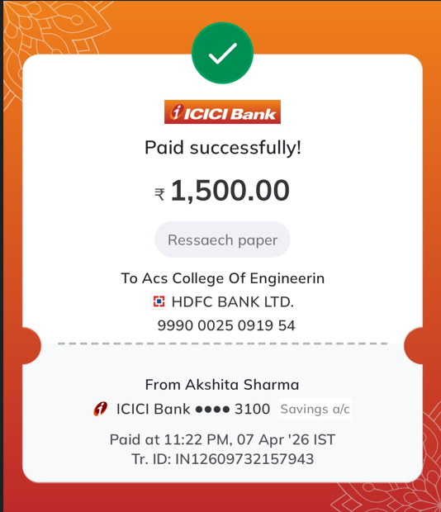
Fig A.2: Conference Payment Proof

APPENDIX C
PUBLICATION DETAILS

The research paper called “Rebound: Centralised Sports Data System” is going to be published in the International Journal of Engineering Research & Technology (IJERT), a well-known journal with the ISSN: 2278-0181, which is published by ERSRA. The authors have completed and submitted a copyright agreement form as part of the registration process for publication.

APPENDIX D
PLAGIARISM REPORT





